Kaleidoscope

Subject:  Related Subjects: | Grade Level(s):  Length of Lesson: | Type: Inquiry / Design / Project  Keywords: Light; wave; reflection; diffuse

Lesson Overview
Students will use bottles and reflecting surfaces to create a device that turns ordinary colored
objects into beautiful array of images.

Lesson Focus
The main phenomenon of this activity is to notice and see patterns from the bouncing reflections of different mirrors.

Lesson Objective(s) | Students will learn that light is a wave, why the wave properties of light are responsible for color, and how light reflects off of mirrors. Students will also learn about angles and geometry, exploring the concept of equilateral triangles.

Lesson Timing

5 minutes | Introduce the Lesson
30 minutes | ...

Materials | - Acrylic mirrors, cut into strips  - Tape  - Poster board pieces  - Small Ziploc bags  - Glitter paper, beads, ribbon, and other small sparkly objects  - Construction paper  - Rubber bands
Instructor Prep | - Step 1
Related Resources | - https://www.wikihow.com/Make-a-Kaleidoscope  - https://babbledabbledo.com/mini-diy-kaleidoscopes-open-ended/

Lesson Plan

Introduction

Primer Questions:
- What are applications of light?
  - Lighting
  - Lasers
  - *Variety of other answers
- What are some things we know about light?
  - They warm things up
  - It’s a form of energy.

Procedure
- Take three mirror strips and form them into a triangle. Secure the mirrors in place with tape and a rubber band

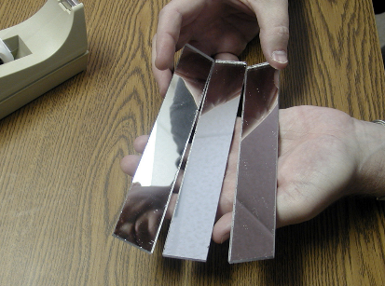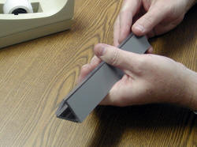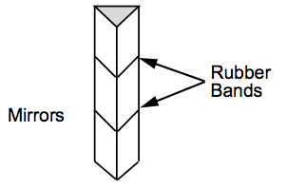
- Roll poster board into a tube, that will fit snugly around the mirror triangle, tape into place

- Fill a small Ziploc bag with sparkly objects
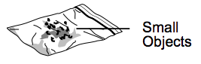
- Secure the plastic bag to one end of the tube using a rubber band
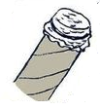
- Take a circle of paper and poke a hole in the center. Tape this paper to the open end of the tube to form a viewing hole
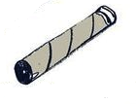
- Hold finished kaleidoscope up to the light to see amazing patterns!
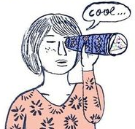

- With any remaining time, decorate the outside of the tube

Wrap-up
- Student uses different shapes and color paper to get different patterns

Lesson Background for Teachers

Suggested Real-World STEM Connections
Yayoi Kusama
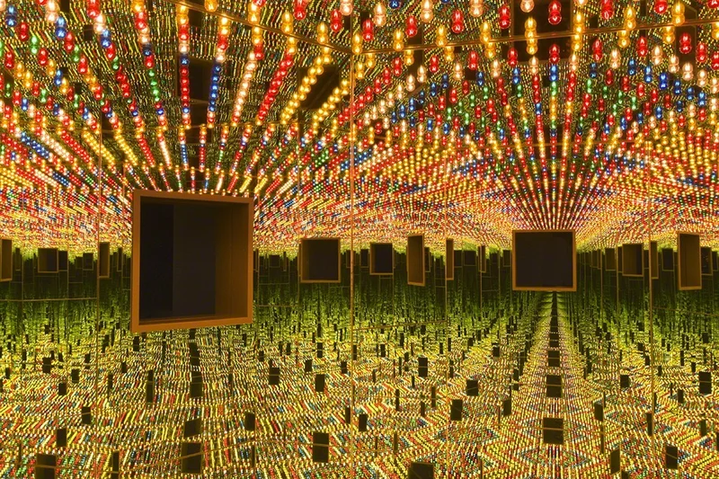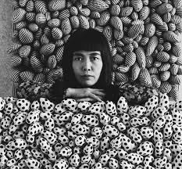

Born in 1929 in Matsumoto, Japan, Kusama’s work has been featured widely in both solo and group exhibitions. She presented her first solo show in Japan in 1952. In the mid-1960s, she lived in New York where she became an important avant-garde artist by staging groundbreaking and influential happenings, events, and exhibitions. In 1965 Kusama produced her first Infinity Mirror Room. Building on the repetition found in her paintings and sculptures, this artwork used mirrors to create an illusion of infinite space. Since then Kusama has made more than 20 unique rooms.

Real World Example
- Lasers
- Ovens
- GPS and Navigation
- Solar Panels

Hypothesis & Prediction
- Students will predict the behavior of light when different mediums are placing between the observer and the opening of the cone

Brainstorm & Design
- Students will attempt to design a unique pattern based off what they know of light
- Students will use the above materials to develop a kaleidoscope
- How will they overcome those constraints?

Build & Create
- As above, students will use all of the materials above with a bit of general guidance in order to create their own kaleidoscopes.

Test & Record
- Students will view through their own created kaleidoscopes and record observations

Assess & Evaluate
- Students will make detailed observations as well as recognize the changes that different colors make to the kaleidoscope patterns.

How to Improve?
- Ask the students what they would improve or change if they were to do it again

Lesson Variations and Options
Different numbers and shapes of mirror/reflective surface alignment can be tried to observe the variation and complexity in patterns created by the mirror and the complex mirror orientation in the tube.

Explanation
When three mirrors of the same size are arranged into an equilateral triangle, rays of light will reflect to form multiple images of any object placed between the mirrors. This is how a kaleidoscope works. The patterns you see through a kaleidoscope are made by light bouncing between the mirrors. When you look through one end of a kaleidoscope, light enters the other end and reflects images of various objects off the mirrors, creating amazing patterns.

Light: Light is a wave, similar to the waves in the ocean. The difference is that light waves are very small. Light waves are all around us, and they interact with every object they encounter. It is light waves that create our perception of colors. To see color, you have to have light. When light shines on an object some colors bounce off the object and others are absorbed by it. Our eyes only see the colors that are bounced off or reflected.
The sun’s rays, and our overhead lights, contain all the colors of the rainbow mixed together. This mixture is known as white light. When white light strikes a white object, it appears white to us because it absorbs no color and reflects all color equally. A black object absorbs all colors equally and reflects none, so it looks black to us. While artists consider black a color, scientists do not because black is the absence of all color.
Mirrors/reflection: A mirror is a shiny surface that can reflect light so well that it preserves any image placed in front of it. This is because a mirror is very smooth, so light reflects off of it evenly. If there is any roughness to a surface, that roughness will cause light to scatter, which distorts an image. What you are actually seeing, when you look in a mirror, is light reflecting off of you! In the daytime, or under artificial lights, light reflects off your body in all directions. That's why you can see yourself and other people can see you. Your skin and the clothes you're wearing reflect light in a diffuse way: light rays bounce off randomly, haphazardly, in no particular direction. Stand in front of a mirror and some of this light from your body will stream in straight lines toward it. This light is reflected directly back off the smooth mirror, and you see your image.

Key Concepts and Vocabulary
- Tube: The main body of the kaleidoscope, typically cylindrical.
- Mirrors: Inside the tube, usually arranged in a triangular configuration. The number and arrangement of mirrors determine the complexity and type of patterns.
- Object Chamber: A container at one end of the tube holding small, colorful objects like beads, glass, or other trinkets.
- Lens: Sometimes placed at the end opposite the object chamber to focus the viewer's eye.
- Eyepiece: The end of the tube where the user looks through.

Safety Notes
- Students should use caution with sharp tools
- Students should use caution with glue guns

